Hello class! How are you today? I hope you are fine.
Today is Thursday and here you have your English work :
2
1
We are doing page 149 and 153 from your books
PAGE 149
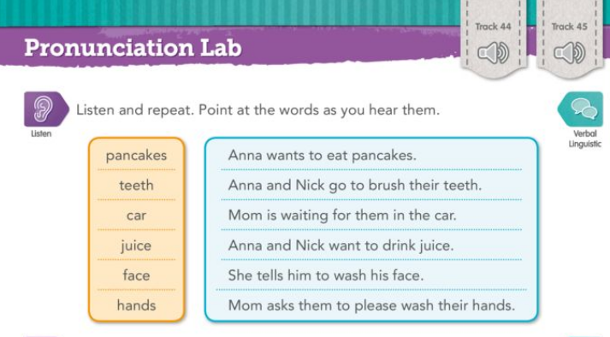
In this exercise you have to do as we did in class: Listen, repeat and number the vocabulary as you hear it. Remember to circle the “mistery Word” . The second audio is just listen, read and repeat.
(En este ejercicio tienes que hacer como hacíamos en clase: escuchar, repetir y poner el número al lado de la palabra en el orden en que la oigas. El segundo audio es para que escuches, leas y repitas)
In this second exercise, you have to order the letters to form a Word from the exercise above.
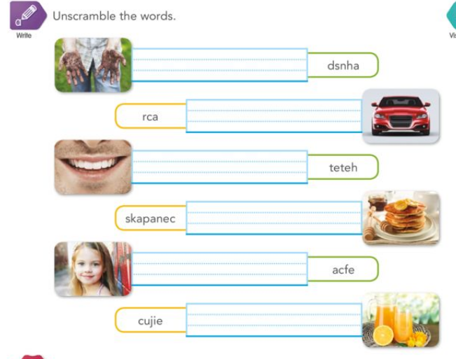
PAGE 153
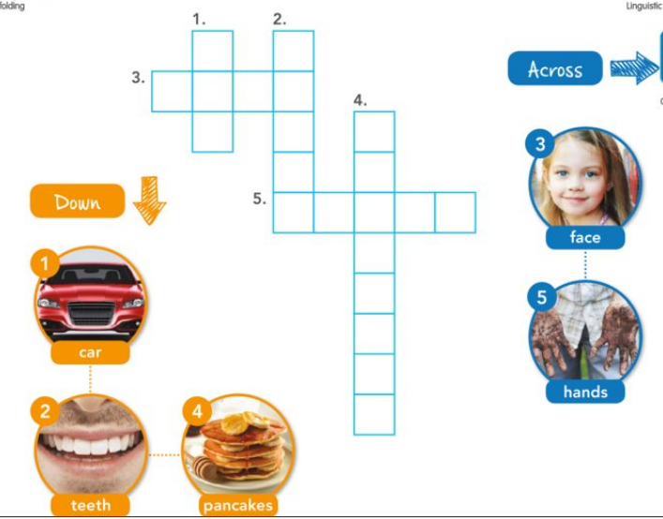
(Qué palabra de la lista de la página 149 no aparece en el crucigrama?

SEND A PHOGRAPH OF YOURSELVES WORKING ON THE BOOK TO mayte@santanafraga.com
(enviad una foto de vosotros mismos trabajando con el libro a mi correo)
THANK YOU!
I MISS YOU ALL!

